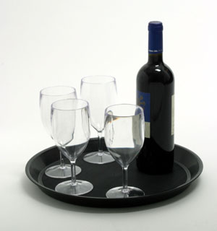

Web link go to products
http://www.akvila.com/index.php/page/products.htm
Hold mouse over thumbnails to show large image
Tulip Range | Universal Range | Top Range

 | No | Description | Dimensions | CE Marked Available
Tulip Range
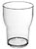 | PC200 | Polycarbonate plastic  Tumbler | Volume 250ml / (8.8 fl oz) to rim  Height 9 cm / 3.6 inches  Diameter max 7.3cm / 2.9 inches
 | PC260CE | Polycarbonate Plastic  Tulip 1/2pt Glass | Volume half pint (10 fl oz) to rim  Height 12cm / 4.8 inches  Diameter max 7cm / 2.8 inches | Government Stamped Half Pint to brim
 | PC300 | Polycarbonate Plastic  Tulip Glass 0.3L | Volume 400ml/14 fl oz to rim  Height 14.5 cm / 5.8 inch  Diameter max 7.5 cm/3 inches
 | PC300CE | Polycarbonate Plastic  Tulip Glass 0.3L | Volume 400ml/14 fl oz to rim  Height 14.5 cm / 5.8 inch  Diameter max 7.5 cm/3 inches | CE Marked
 | PC400 | Polycarbonate Plastic  Tulip Glass 1Pt | Volume 480ml/17 fl oz to rim  Height 15.3 cm / 6.1 inch  Diameter Max 8 cm/3.2 inches
 | PC450 | Polycarbonate Plastic  Tulip 1pt Glass | Volume pint (20l oz) to rim  Height 14.75cm/5.8 inches  Diameter max 9cm/3.5 inches | CE Marked
 | PC500 | Tulip Glass 0.5L | Volume 630ml/22 fl oz to rim  Height 17 cm / 6.8 inch  Diameter Max 7.6 cm/3.04 inches
 | PC500CEL | Tulip Glass 0.5L | Volume 630ml/22 fl oz to rim  Height 17 cm / 6.8 inch  Diameter Max 7.6 cm/3.04 inches | CE Marked
Universal Range |  |  |  | [Top]
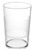 | PC251 | Universal Glass | Volume 280ml/10 fl oz  Height 10 cm / 4 inch  Diameter Max 7.25 cm / 2.9 inches
 | PC251CE | Universal Glass | Volume 280ml/10 fl oz  Height 10 cm / 4 inch  Diameter Max 7.25 cm / 2.9 inches | CE Marked
 | PC301 | Universal Glass 0.3L | Volume 350ml/ 12.3 fl oz  Height 14cm/5.6 inches  Diameter Max 7cm/2.75 inches
 | PC301CEL | Universal Glass 0.3L | Volume 350ml/ 12.3 fl oz  Height 14cm/5.6 inches  Diameter Max 7cm/2.75 inches | CE Marked
 | PC401 | Universal Glass 0.4L | Volume 500ml/17.6 fl oz  Height 14.2cm/5.75 inches  Diameter Max 8cm/3.1 inches
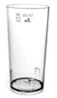 | PC501 | Universal Glass 0.5L | Volume 650ml / 22.87 fl oz  Height 16cm /6.25 inches  Diameter Max 8.5cm/3.3 inches
 | PC501CEL | Universal Glass 0.5L | Volume 650ml / 22.87 fl oz  Height 16cm /6.25 inches  Diameter Max 8.5cm/3.3 inches | CE Marked
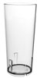 | PC601 | Universal Glass 0.6L | Volume 750ml /26.4 fl oz  Height 18cm/7 inches  Diameter Max 8.75cm/3.5 inches
 | PC601CEL | Universal Glass 0.6L | Volume 750ml /26.4 fl oz  Height 18cm/7 inches  Diameter Max 8.75cm/3.5 inches | CE Marked
Top Range |  |  |  | [Top]
 | PC150S | Polycarbonate plastic  Champagne Glasses | Volume 180ml (6.33 fl oz) to rim  Height 17.2cm / 6.9 inches  Diameter Max 5.8cm / 2.32 inches
 | PC150SCEL | Polycarbonate plastic  Champagne Glasses | Volume 180ml (6.33 fl oz) to rim  Height 17.2cm / 6.9 inches  Diameter Max 5.8cm / 2.32 inches | CE Marked at 150ml
 | PC 180S | Polycarbonate plastic  Small Wine Glasses | Volume 200ml / (7fl oz) to rim  Height 14.9cm / 6 inches  Diameter Max 6.7cm / 2.7 inches
 | PC 180SCEL | Polycarbonate plastic  Small Wine Glasses | Volume 200ml / (7fl oz) to rim  Height 14.9cm / 6 inches  Diameter Max 6.7cm / 2.7 inches | Government Stamped at 125ml
 | PC280S | Polycarbonate plastic  Large Wine Glasses | Volume 315ml (11fl oz) to rim  Height 16.1cm / 6.5 inches  Diameter Max 7.7cm / 3.1 inches
 | PC280SCEL | Polycarbonate plastic  Large Wine Glasses | Volume 315ml (11fl oz) to rim  Height 16.1cm / 6.5 inches  Diameter Max 7.7cm / 3.1 inches | Government Stamped at 175ml
 | PC260S | Polycarbonate plastic  Martini Glasses | Volume 350ml (12.28 fl oz) to rim  Height 17.5cm / 7 inches  Diameter max Max 11.75 cm / 4.7 inches
 | PC260SCEL | Polycarbonate plastic  Martini Glasses | Volume 350ml (12.28 fl oz) to rim  Height 17.5cm / 7 inches  Diameter max Max 11.75 cm / 4.7 inches | CE Marked at 250ml
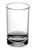 | PC41 | Polycarbonate plastic  Shot Glasses | Volume 55ml (2.1 fl oz) to rim  Height 6cm / 2.4 inches  Diameter max 3.8cm / 1.52 inches
 | PC41CEL 25ml | Polycarbonate plastic  Shot Glasses | Volume 55ml (2.1 fl oz) to rim  Height 6cm / 2.4 inches  Diameter max 3.8cm / 1.52 inches | CE Marked at 25ml
 | PC41CEL 35ml | Polycarbonate plastic  Shot Glasses | Volume 55ml (2.1 fl oz) to rim  Height 6cm / 2.4 inches  Diameter max 3.8cm / 1.52 inches | CE Marked at 35ml
 | PC41CEL 50ml | Polycarbonate plastic  Shot Glasses | Volume 55ml (2.1 fl oz) to rim  Height 6cm / 2.4 inches  Diameter max 3.8cm / 1.52 inches | CE Marked at 50ml to rim
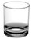 | PC201 | Polycarbonate plastic  Rocks Glasses | Volume 275ml (9.65 fl oz) to rim  Height 8cm / 3.2 inches  Diameter max 7.4cm / 3 inches
 | PC261CE | Polycarbonate Plastic  Straight Deluxe 1/2pt Glass | Volume half pint (10 fl oz) to rim  Height 11.75cm / 4.7 inches  Diameter max 7cm / 2.8 inches | Government Stamped Half Pint to brim
 | PC281 | Polycarbonate plastic  Hiball Tumbler | Volume 325ml (11.44 fl oz) to rim  Height 15cm / 6 inches  Diameter max 6cm / 2.4 inches
 | PC281CEL | Polycarbonate plastic  Hiball Tumbler | Volume 325ml (11.44 fl oz) to rim  Height 15cm / 6 inches  Diameter max 6cm / 2.4 inches | CE Marked at  1/2 pint
 | PC451CE | Polycarbonate Plastic  Straight Deluxe 1pt Glass | Volume Pint (20 fl oz) to rim  Height 17.25cm / 6.9 inches  Diameter max 8cm / 3.2 inches | CE Marked 1 Pint to brim
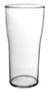 | PC452CE | Polycarbonate Plastic  Tulip Deluxe 1pt Glass |  | CE Marked 1 Pint to brim
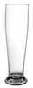 | PC502 | Polycarbonate Deluxe Pilsner Glass | Volume: 600ml / 22oz to the rim  Height: 9.25ins / 23.5cm  Diameter Max: 3ins / 7.5cm
 | PC502CEL | Polycarbonate Deluxe Pilsner Glass | Volume: 600ml / 22oz to the rim  Height: 9.25ins / 23.5cm  Diameter Max: 3ins / 7.5cm | CE Marked to 1pint Line
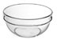 | PC11D | Polycarbonate Plastic Snack Bowl | Volume: 300ml / 10floz to rim  Height:  Diameter Max: 11cm / 4.4 inches
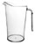 | PC1501 | Polycarbonate plastic  Pitcher | Volume 1.9 litre (67 fl oz or 3.34pints) to rim  Height 22.4cm / 9 inches  Diameter Max 15.4cm / 6.16 inches

[Top]

HOME |  | ABOUT US |  | CONTACT US |  | PRODUCTS

Non-Slip Trays  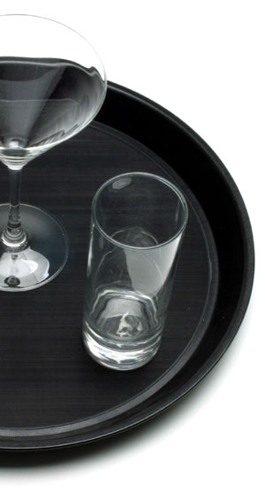
  'Wet Grip' non-slip surface
  Fibreglass reinforces
  Dishwasher Safe
  Guaranteed against breakage for 5 years
  Low Order Volumes
  High Quality Print
  Competitive Prices
  35cm Diameter
  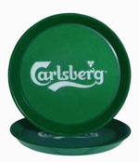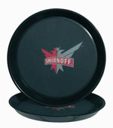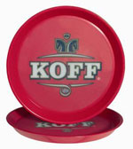
  Akvila Oy – quality since 1920  Akvila Oy, founded in 1920, is the leading producer of polycarbonate tableware and disposable cutlery in Scandinavia. | 
  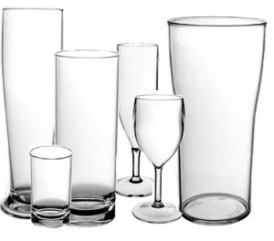 | With over 50 years of experience in injection moulding we have established a solid base of know-how.  We are constantly active in developing our production technology, which enables us to keep delivery times short and production costs low. We are proud to introduce Akvilaดs line of high quality products.

